**Project PhysX Design Document**

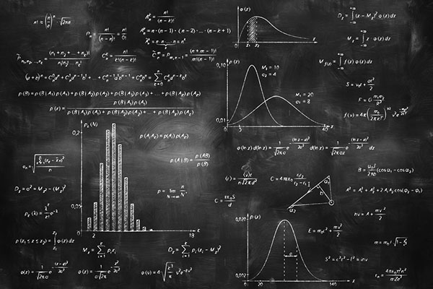

**Development Team:**

Jefferson Le

Tyler Pinho

Curtis Spence

CSE 494

Professor Nelson

Table of Contents

Table of Contents 1

Section A. Instructional Design Plan 2

Instructional Problem and Proposed Solution 3

Rationale for a Virtual World 4

Target Audience and Instructional Setting 4

Learning Objectives 5

Description of Treatment 6

Content Outline 7

Program Flow 8

Proposed Timeline 9

Proposed Budget 9

Section B. Detailed Outline of the Instructional Flow 10

Description of the Virtual World and Goals 11

Overall Expected Duration of Curriculum 11

Virtual World Setting 12

Introductory Message 12

Actions and Tools Employed 13

Quests 14

1. Introduction to Physics 14

2. Mass/Size 15

3. Force 16

4. Gravity 17

Section C. World Maps 18

Section D. GUI Mock-Ups 19

Section A. Instructional Design Plan

Instructional Problem and Proposed Solution

When choosing what science classes to take, through middle school to college, students often decide to move away from, or avoid, Physics classes. Physics as a whole has built up a reputation  in our culture as being an extremely difficult and imposing principle. Despite this though Physics is a very fundamental building block in our understanding of the world and the sciences and as such it’s important that students have at least a basic understanding of Physics to ensure future success in STEM fields or at least the choice to pursue such things.

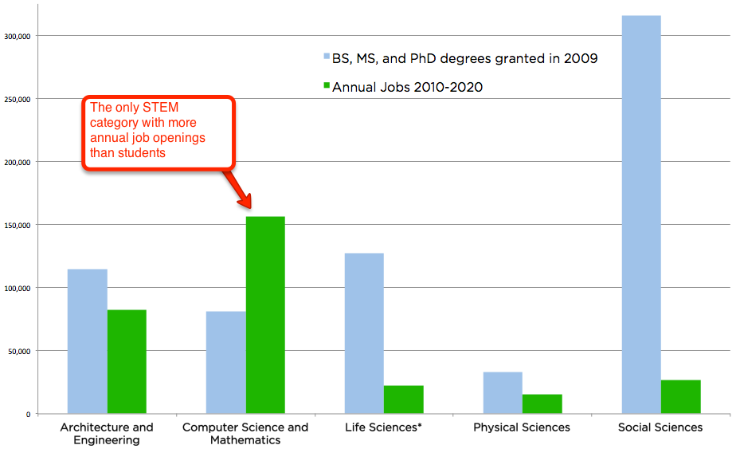

The graph above shows that not only are there fewer job openings annually for physics related positions, but that of all STEM fields Physics also has the lowest numbers of students as well. Since Physics is the foundation of so many fields, the lack of new blood and innovation in Physics will in turn create the same lack of innovation in other STEM fields as well. For example, lack of progress in physics will make it difficult to design new buildings to accommodate rising populations and food demands, advancements in physics need to be made in order for radical designs and materials to be realized for the future.

As such in order to help students develop these skills we propose to create a virtual world where students will practice their Physics basics in a way which will help dispel their fears surrounding the topic. To facilitate this the virtual world students will be participating in will be structured similarly to popular building destruction games like Angry Birds. During these games students will be presented with a variety of exercises that will build their skills in Physics such as finding the correct numbers to achieve a certain arc height when shooting a cannon. In this way the virtual world will already be familiar to students and help lower their reservations while also raising their engagement assisting them in learning much better than the more abstract lessons and exercises they are used to.

Rationale for a Virtual World

A computer-based program is the best solution for this instructional problem because students today are much more used to acquiring knowledge through technology then they are though traditional teaching methods. Physics as a subject fits particularly well for this because physics is utilized for most of the technological entertainment students consume. As such physics is already a part of the things students interact with daily and a virtual world is the best way to make this obvious to them and increase their engagement and learning. In addition by using a virtual world students can further enhance their understanding beyond what can be done in a classroom by being able to experience simulations of things they are unable to experience like the physics of space. Problems that use highly abstracted environments and variables are common in Physics (ie. environments without air resistance) and are often confusing for students and by using virtual worlds it becomes much easier to demonstrate these problems and the differences between them as a live visual representation that could not easily be shown now can be shown directly to the students.

Target Audience and Instructional Setting

The target audience for this is primarily middle school students, between the ages of 12-15, the primary reasoning behind this is that this is around the earliest time in which students are first introduced to the subject of Physics. We wish to target both male and female students equally well as well as target students of all ethnicities and backgrounds. However since this is a virtual world the target audience is going to be primarily thought of as middle class, with easy access to a computer and the internet in order to acquire the software. The instructional setting is primarily thought of as the student’s own self learning and environment and manner in which they choose to play the game which could either be in order to enhance their understanding of the subject or as a leisure activity for their enjoyment. It can also be employed in a classroom setting by teachers as a tool to help teach students as either another exercise to be used such as having the students play specific levels to illustrate difficult concepts, or for example as a consistent activity throughout the curriculum such as assigning some amount of levels per week as homework, creating a community around the game as students work together to overcome that week’s tasks.

Learning Objectives

The goal of this virtual world will be to provide a fun and immersive way for middle school students to learn of planetary physics and physics in space as well as how each of the physics equations is used in different scenarios. This game will rely on using Cognitive Apprenticeship via using a fun narrator to provide short learning lessons, objectives, and quirky fun dialogue in order to keep the lessons informative but not overbearing. Our virtual world will also use Constructivism by providing goal-based, fun levels that teach people lessons through actually performing the physics being taught.

Objectives

* Effects of Gravity
* Newton’s Three Laws of Motion
* Newton’s Law of Universal Gravitation
* Relation of Acceleration and Velocity
* Relation of Velocity and Position
* Effect of Mass on Force
* Learning How Each Physics Equation Applies to the World

**Sample Assessment Items**

1. Increasing the Force on an object will cause what else to increase?
   1. Mass
   2. Friction
   3. Gravity
2. When a ball rolls on grass it has more friction than rolling on ice?
   1. True
   2. False
3. Newton’s 1st Law: An object in motion remains in motion unless ________
   1. Acted on by an outside force
   2. Friction is zero
   3. It collides with another object
   4. 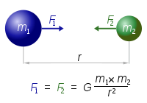Acceleration is zero
4. What concept does the following figure represent?
   1. Newton’s 3rd Law
   2. Planetary Collision
   3. Newton’s Law of Universal Gravitation
   4. Orbits of Celestial Bodies

Description of Treatment

The virtual world will be a third-person puzzle-action game that takes a similar approach in game design to Angry Birds or Boomblox. The environments will be a hands-on experience where students will actively learn physics concepts through completing specialized stages that rely on utilizing a certain physics concept to destroy all of the blocks in the level in a limited number of attempts. This is done through the student learning about and manipulating the input of physics equations both on environments on Earth as well as in space.

There will be an in-game narrator that serves as the mentor for the player that provides them the learning objectives and advice on how to complete the level. The virtual world will have 4 sub-worlds built in with each having several stages. There are quizzes featured at the end of each world to test mastery and once all 4 quizzes are completed the player wins. Altogether this virtual world should take 30 minutes for a first time player to complete but may take up to 50 minutes depending on how well they can complete each level.

The entire project is virtual so no additional materials are going to be needed. All directions, testing, and teaching will be located in the game. The problems being tested are conceptual in nature so scratch paper and a calculator are unneeded but a strong willingness to learn new concepts will be needed.

Due to the whole experience being self-contained in the program, the instructor just needs to allow the students to play the game with no other additional procedures. The instructor can opt to make the experience more guided but that will not be covered in this virtual world as it is viewed to be optimal to have the students self-pace themselves in order to learn the best.

Content Outline

1. Title Screen
   1. Virtual World Title with Animated Screen
   2. Authors
   3. Credits
   4. Copyright
   5. Start Game
   6. Continue Game
   7. Options
2. Introduction
   1. Welcome
   2. Introduce Mentor Character
   3. Directions
   4. Learning Goals
   5. Tutorial Levels
3. World Map
   1. Four Worlds
      1. Intro to Physics
      2. Mass/Size Manipulation
      3. Force Manipulation
      4. Gravity Manipulation
   2. HUD
      1. Show Stars and Mega Stars Earned
      2. Display Physics Concepts Taught In a Level
      3. Current Level Name
   3. Levels
      1. Custom-Made to Highlight Specific Physics Concept
      2. Relevant to World Located In
      3. Mentor Provides Dialogue
4. Quiz Section
   1. Completed At End of Each World
   2. If Student Failed Quiz Link Back to Relevant Levels
   3. Completing All 3 Quizzes Leads to Completion
5. Completion
   1. Final Mentor Words
   2. Certificate of Completion
   3. Link Back to Title Screen

Program Flow

1. Title Screen

The game starts with the title showing overlaid on an animated backdrop of some in game scenery. The play start game button starts the game for the player, going into the introduction. Continue will bring the player to the level select screen with the amount of progress they have previously done showing. Options will bring up a volume control, a toggle for showing the tutorial/intro. Credits will show the names of the contributors to the project. Elsewhere on the screen will be copyright labels and the authors’ names.

1. Introduction

The intro will begin with a welcome screen via the virtual world Guide. After a brief introduction, the Guide will explain the basic game objective and mechanics to the player. On top of this, the learning objective of understanding various physics applications will be told to the player. From here, the player will enter a series of walkthrough levels that allow them the apply the mechanics they were told of as well as learn about the various game components they will encounter throughout the game.

1. World Map

From this screen, the player may navigate and select various regions based on different topics within the large spectrum of Newtonian physics, from planetary gravity to weightless physics and then finally the Advanced planetary physics. Within these regions will be various levels that pertain the world they reside in and will generally increase in complexity as they progress through their worlds. Selecting an unlocked/available level will send the player into the game where they will enter and manipulated various physics equations to achieve some goal for the level explained by the Guide. There will be a counter on the world map of how many levels have been completed compared to the total. Also, a back button to return to the main screen.

1. Post-World Assessment

After a world has been completed, an assessment of the player will be given in the form of a small quiz in order to determine the material they retained from the related world lessons. If failed, the player will be sent back to the levels related to the failed quiz material in order to let them relearn and hopefully hold onto the knowledge. Once all 3 quizzes are complete, the Completion screen will show.

1. Completion

The player wins! The Guide congratulates the player, a certificate is awarded, and the player is sent the start screen.

Proposed Timeline

|  |  |  |
| --- | --- | --- |
| **Section** | **Time (hours)** | **End Date** |
| Project Proposal | 5 | 9/27 |
| Proof of concept for different Physics interactions | 6 | 10/10 |
| Physics Equation to Gameplay Interaction | 8 | 10/17 |
| Project Design Doc | 6 | 10/19 |
| GUI Design | 15 | 11/7 |
| Scripting various physics elements | 20 | 11/9 |
| Level/World Design | 50+ | 11/14 |
| Texture/Modeling Design | N/A | 11/14 |
| Finish/Revise Week | 5-10 | 11/21 |

Proposed Budget

|  |  |  |
| --- | --- | --- |
| **Subject** | **Amount** | **Cost** |
| Custom Built Development PCs | 3 x $1300 | $3900 |
| Cintiq Artisan Pad | 1 x $2000 | $2000 |
| Unity Professional Licenses | $1500 | $1500 |
| Scripters Fee | 250 hours x $45 | $13,500 |
| Artists/Modelers Fee | 40 hours x $55 | $2200 |
| Food (Preferably Ike’s) | 2000 Sandwiches | $20,000 |
| **Totes** | **---** | **$41,300** |

Section B. Detailed Outline of the Instructional Flow

Description of the Virtual World and Goals

Our virtual world will take place on an Earth-like 3D planet. The player will navigate to different parts of the planet and enter a variety of levels with different environments contained within each stage. An example of this is the first level takes place in a large jungle zone with a castle in the middle, while the next stage takes place within the suburbs of a city.

The player will control a cannon from a third person perspective where they will have the ability to control when and where the cannon will fire as well as being able to manipulate different physics components of the stage in order to complete the level. Depending on the stage the player can change the mass and size of the cannon-ball or in another stage may be able to modify how much gravity there currently is on the planet. The game will play out in a similar fashion to Angry Birds and other physics shooters where the goal is to destroy a structure in a limited number of shots. This is the main goal of the player and serves as a fun way to teach students how different physics properties interact with each other in a "sandbox" environment.

Players will have to use their physics knowledge they’ve accumulated in order to knock down the structures. Each grouping of levels will serve the purpose of highlighting a different core concept of Physics, for example one grouping of levels serves to teach about how mass/size affects how the cannonball travels with other groupings including force, gravity, and the basics of physics as well.

The ultimate goal of the of the virtual world is that by the end of their journey, players will have an in-depth knowledge on the basics of physics as well as some of the key factors that affect the physics that govern our world such as Mass/Size, Force, and Gravity. These goals and any other concepts taught are aimed to be taught to a middle-school level of knowledge on physics and by the end of the curriculum of the virtual world players should be comfortable in both their knowledge of physics and the ability to use these concepts together in tandem to solve physics related problems both in and outside the classroom.

Overall Expected Duration of Curriculum

In an ideal scenario, a player is expected to take around 15 minutes to complete each level. This is taking into account this is the first time a student has attempted a stage. Like a puzzle, subsequent attempts should take less time. This time estimate also includes all facets of a level's experience from selecting the stage on the world map, entering the level, having the mentor character (Stan the Owl) provide commentary, tinkering with the physics, and finally taking the multiple shots required to destroy a given structure. However this expected time could reasonably be as high as 30 minutes per level as well on first attempt depending on how much a student can adapt to each new introduced physics concept. Due to the additional layer of physics learning each level has, it may take players some additional time to figure out how to take down each structure as a guess and check method that could be used in other “catapult” type games is not sufficient.

Virtual World Setting

The setting of the virtual world is a planet similar to earth. On it players travel to a variety of different locales to shoot at buildings and other architectural structures made up of many different blocks and block types from a cannon. The locales are constructed in such a way that the cannon is higher up on some ledge or plateau and the player shoots down onto the building from there. There are many different locales where a variety of levels take place to teach a core concept of physics. Some locales include a tropical setting, a desert setting, a plains setting, a forest setting, suburban environments, and more.

Introductory Message

Upon booting up the game and entering the virtual world for the first time the player will be greeted with a title screen where they can either choose to exit the program, start the game, or view the instructions on how to play. Once they enter the game, the player will be placed into the first tutorial level and given the following message.

“Welcome to Project PhysX, here you can discover the wonders of the universe and the building blocks of all science. To complete each level in this game you’ll have to knock down and destroy each of these structures completely. But wait! This isn’t your typical catapult game! In Project PhysX if you want to show those blocks what’s up you’ll need to apply some physics knowledge! We’ll be teaching you what you need to know along the way, so for now just learn how to shoot. Use the white preview path from your cannon to line up your shots. Line it up with the red one on screen to knock down this castle! This one is a freebie and the red-line won’t be in later levels. Good Luck and get ready for some PhysX!”

Actions and Tools Employed

**Tool List:**

1. Cannonballs - These are the ammunition in the game and a player has a limited number of cannonballs per level. After they are depleted if the structure isn't destroyed the player fails the stage.
2. Cannon - The object that the player controls. Fires the cannonballs that will destroy the structure. It is stationary but can be tilted left, right, up, or down to aim at different parts of the level. There is also an aiming reticule to help the player better understand where their shot will end up after firing. This is available only within a level.
3. Change Physics - The main gimmick of the game. This button is available in all levels and allows for the player to manipulate a preset selection of different physics attributes of a stage ranging from mass of the cannon ball to the force behind the cannon. This allows for the player to take on stages in the most optimal fashion and learn how different physics components operate in a real world environment.

**Character List:**

1. Stan the Owl - Stan is the narrator of the game and provides short, witty comments to the player and guides them through the various levels and worlds of the game. Stan will also provide short tips on different physics concepts to reinforce certain ideas in each level. Appears on the HUD whenever new information is needed for the player.

**Object list:**

1. Building Blocks - These are basic blocks with a predefined and uniform size and mass across all levels. These blocks come in a variety of colors and are used to construct each structure that must be destroyed in each level.
2. Explosive Blocks - On violent collision or hit from the cannon ball, these blocks will explode and impact other nearby objects allowing for easier demolition of structures.
3. Void Block - An incredibly dense and dark block that acts much like a black hole, effecting any object around it and pulling it into an orbit around the Void Block.
4. Ghost Block - This blinking block will change between being solid and being ghost-like allowing for other objects to pass through it.
5. Chain - Acts like rope, swings around, has other objects tethered to it
6. Flags - Shows wind direction in certain stages and serves as one type of
7. Glass Block - Shatter prone block that could break with just one touch. Unlike Explosive blocks these will not send out an additional explosion.
8. Reinforced Block - No matter what happens, this block cannot be moved, destroyed, etc. This block does not have to be destroyed to pass a level.
9. Propulsion Pad - Nonphysical object that causes any objects it collides with to have a large force applied to them in the indicated direction on the pad.
10. Wind Fields - Shown by flags, these areas will effect any object by applying a constant force in the indicated direction.

Quests

1. Introduction to Physics
   1. Introduction to Physics intends to get the player thinking in terms of basic physics processes. Basic lessons and interactions with the tools will adjust the player for playing the rest of the game. This will also include lessons on how to operate the cannon and the goals of each stage to acclimate the player to both the game components and the educational components.
   2. World map, first area
   3. The guide appears and leads the player to starting the game, thus putting them in this quest.
   4. For completing every quest, the player will be rewarded stars based on how many cannon shots it took them to solve the challenge in with more stars rewarded for fewer shots taken. There will also be a mastery award for completing each area so that they realize they have learned everything in a specific discipline.
   5. For all quests, the only NPC interaction will be the guide. The tools will remain the same throughout, only gaining new ones as more areas are explored. The dialog will be explaining what needs to be done.
   6. Time Needed: 5-10 minutes per level

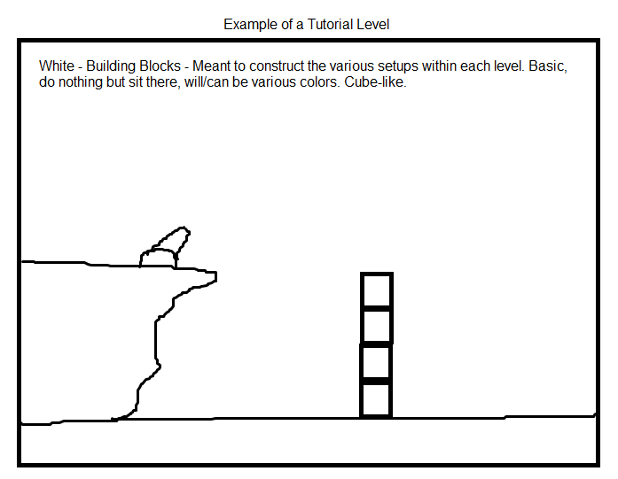

1. Mass/Size
2. Mass and Size deals with changing the mass and size of the cannon projectile to make it interact differently when shooting and hitting objects.
3. World map, second area
4. After completing the first intro area, the player is introduced to the changing functionality of the game and then led to this area.
5. For completing every quest, the player will be rewarded stars based on how many cannon shots it took them to solve the challenge in with more stars rewarded for fewer shots taken. There will also be a mastery award for completing each area so that they realize they have learned everything in a specific discipline.
6. For all quests, the only NPC interaction will be the guide. The tools will remain the same throughout, only gaining new ones as more areas are explored. The dialog will be explaining what needs to be done.
7. Time needed: 10-15 minutes per level

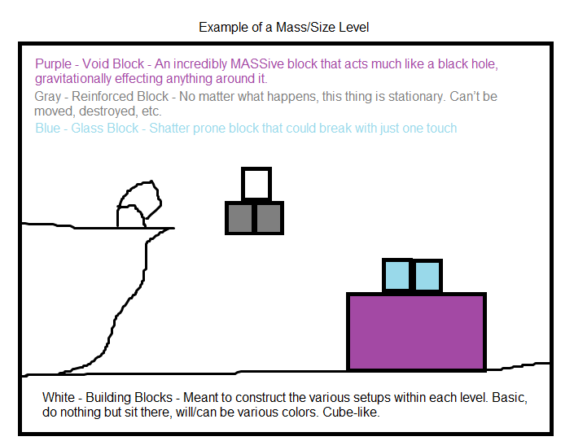

1. Force
2. After understanding how the various sizes and densities of the projectile effect the outcome, the player then gains control of the force of the cannon. More force = faster projectiles. In this area, there will also be the wind and pad blocks that will start showing up, seeing as they are related to “force”.
3. World map, third area
4. Once the second area is complete, the guide appears and leads the player to the third area
5. For completing every quest, the player will be rewarded stars based on how many cannon shots it took them to solve the challenge in with more stars rewarded for fewer shots taken. There will also be a mastery award for completing each area so that they realize they have learned everything in a specific discipline.
6. For all quests, the only NPC interaction will be the guide. The tools will remain the same throughout, only gaining new ones as more areas are explored. The dialog will be explaining what needs to be done.
7. Time needed: 10-15 minutes per level

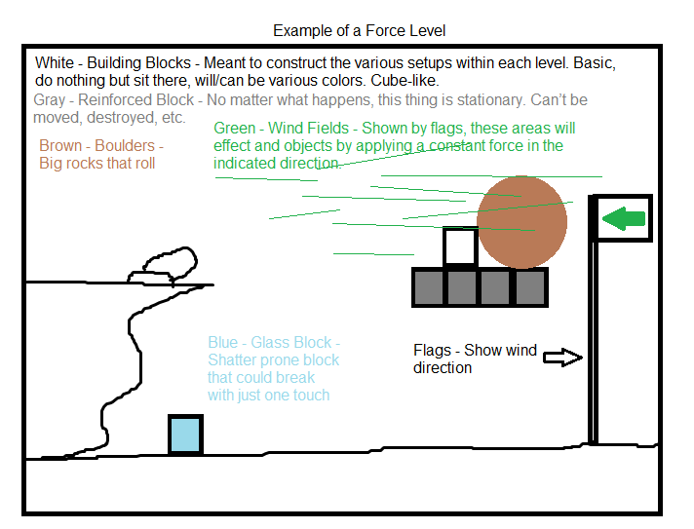

1. Gravity
2. The gravity area will allow the player to not only effect the various attributes from the previous areas, it will also allow the player to change the gravity of the level. Placing the gravity somewhere in between the Moon’s and the Sun’s gravitational pull, the player will learn the effects of gravity on the outcome of various levels. Also, the void block will begin appearing in this area.
3. World map, fourth area
4. Once the third area is complete, the guide appears and leads the player to the gravity area
5. For completing every quest, the player will be rewarded stars based on how many cannon shots it took them to solve the challenge in with more stars rewarded for fewer shots taken. There will also be a mastery award for completing each area so that they realize they have learned everything in a specific discipline.
6. For all quests, the only NPC interaction will be the guide. The tools will remain the same throughout, only gaining new ones as more areas are explored. The dialog will be explaining what needs to be done.
7. Time needed: 15-20 minutes per level

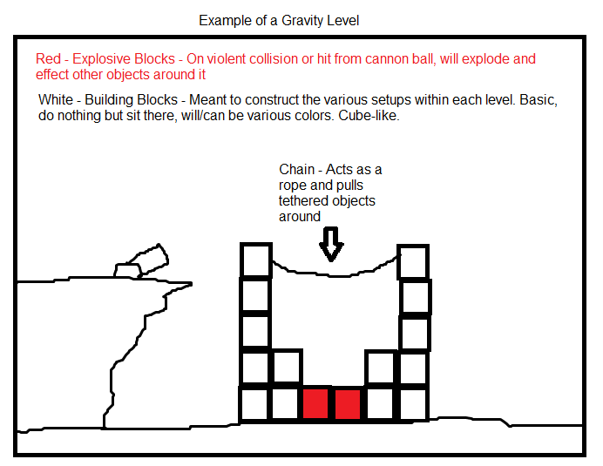

Section C. World Maps

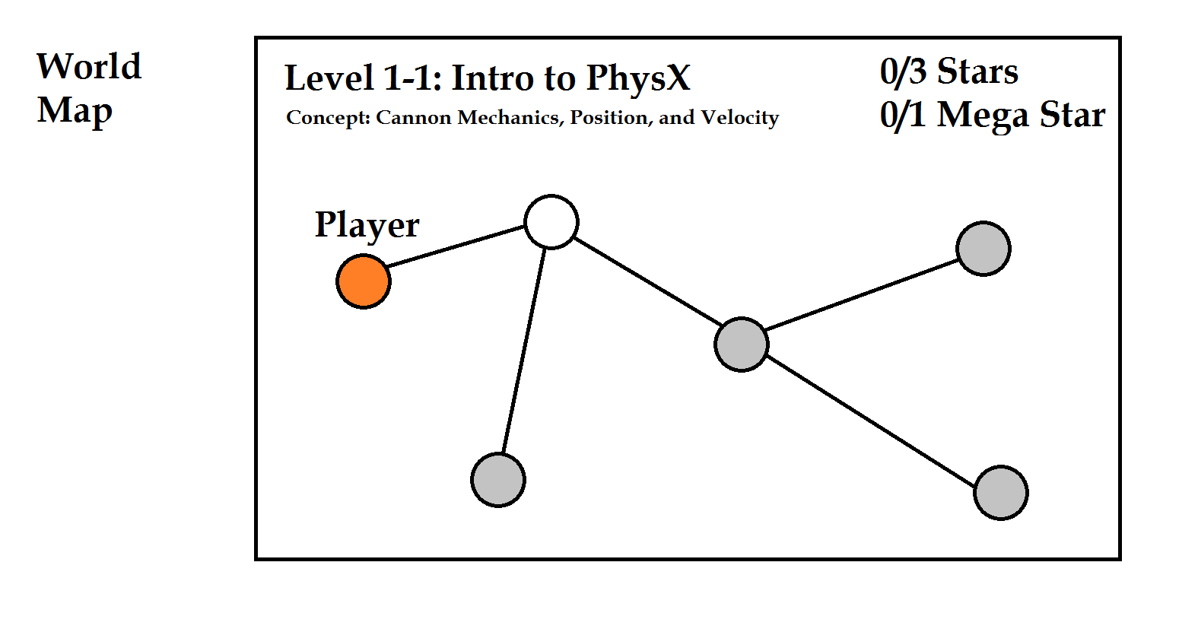

The final world map will be more detailed and have an animated 3D background. There will also be a sprite to indicate the player allowing for the player to identify clearly where on the world map they are and where they can advance to next, assuming they have beaten the current stage. In the above diagram, this concept is represented by the orange circle. Each circle would be a stage that the player has to complete to obtain complete mastery of physics. After completing all the stages in a world the player earns a Mega Star which signifies mastery over all concepts in a world. The grey levels represent stages not yet unlocked. The player has to defeat the previous stage to unlock the rest of the stages connected to it.

Section D. GUI Mock-Ups

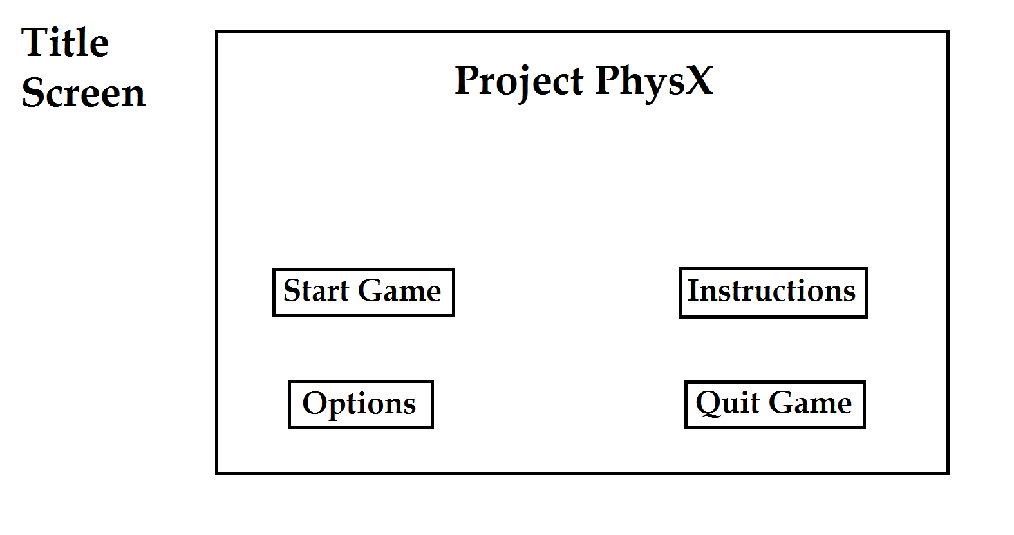

The title screen will be very basic and will contain an animated 3D Background overlooking one of the levels of the game. Under options certain traits like screen resolution and other computer specific traits can be toggled to give students a better experience. The Instructions section will go over the purpose of the game and basic controls which will also be explained within the levels as well as the student comes across different aspects of the game.

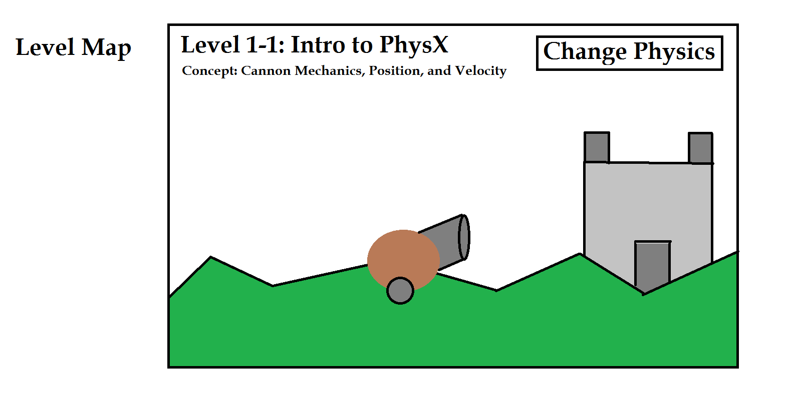

The Level Map will change based on each levels structure but the consistent components will be the level's name, concepts being taught, a cannon that the player controls through the arrow keys, a structure to be destroyed, and the change Physics button. This button when clicked on by the player will pull up a new overlay that contains all the properties of the level that can be altered like the picture below.

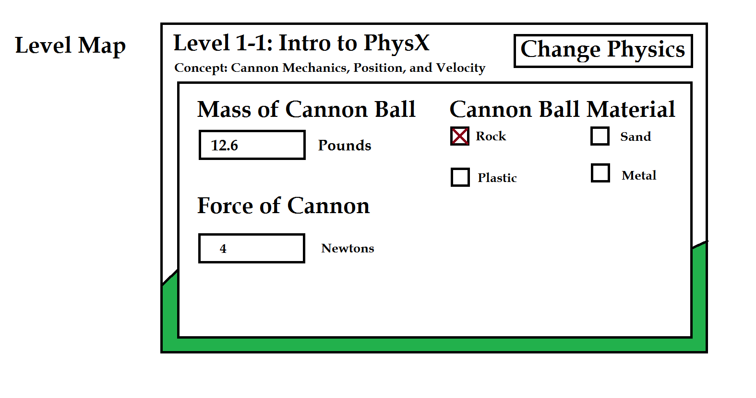

This panel can be closed by hitting the Change Physics button again. This as well as how altering each physics trait will be explained in game by the mentor character.